<https://retrogamesultra.com/2019/02/17/sega-dreamcast-gdemu-installation-and-setup/>

SEGA Dreamcast GDEMU installation and setup

Posted on [February 17, 2019](https://retrogamesultra.com/2019/02/17/sega-dreamcast-gdemu-installation-and-setup/) by [retrogamesultra](https://retrogamesultra.com/author/retrogamesultra/)

**IMPORTANT:** Doing any of the modifications on this page, especially the one to the power circuit, are entirely at your own risk.

**Preamble:**

My waned love for the Dreamcast was recently rekindled due to a desire to play Crazy Taxi. I connected it all up, and got my games out. Alas, the Crazy Taxi disc was missing. As I have a launch model, it runs backups without needing a boot disc, but I had to wait while the burn took place, and then cross my fingers that it was successful. I used to have a fairly good original game collection, but sold a lot of them long ago (the most familiar of woeful tales to so many of my generation). Most of the games I sold are obviously the ones I want to play, too. My PAL version of Rez was parted with during a desperate period of my life for about a tenner. Oh, the regret!

Not only are the optical discs themselves deteriorating, but the laser units in the GD drives also have a finite lifespan, and repairing them could become costly, if parts even keep being made. Burning fresh copies of games solves the first problem, but not the latter. Step in, GDEMU…

**A word on clones:**

…or in this case, step in GDEMU clone. I’m not going to get too deep into the politics of this; I know clones are a shady industry, and suck for the originator of GDEMU. I’m also a creative, and have seen my work plagiarised so that somebody else gained commercially. It’s not a good feeling, but one has to move on, and accept that it will happen. As individuals, we don’t have the legal means to fight every wrong against us. I couldn’t let it stop me creating, but everyone is different. We live in a capitalist world, and cloning in different contexts has been happening for as long as humans have been making stuff (flint arrowhead, anyone?). That’s not justification for it, but it always has, and always will happen. It’s just that our modern understanding of intellectual property is vastly different and more developed than that of our ancestors.

That said, if you want to buy one from the inventor, he opens pre-order queues periodically, and the official site can be found [**here**](https://gdemu.wordpress.com/)**.** Indeed, the installation pages he has helped me out, so do visit it. And like I say, if while you’re there your moral compass settles, please do support him and buy an original.

As a small concession to the creator, I won’t link to the one I bought, but if you want one, you’ll be able to find listings easily enough. Now, on with the installation…

**Do you have the right Dreamcast:**

**IMPORTANT:** There are different models of Dreamcast, and the GDEMU will **ONLY** work with the VA1 model (also known as the second generation). The easiest way to tell if yours is a suitable model, is to look for a number 1 in a circle on the label on the underneath of your Dreamcast, like this:

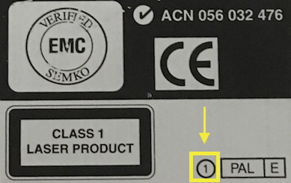

Most second generation models also have a black plastic fan that you can see through the vent grills on the side, whereas first gen machines have metal fans.

If you suspect the case might not belong to the board inside for some reason, you can also verify it by looking for a 1 in a circle on the board attached to the joypad ports, like this:

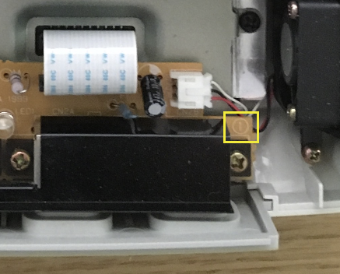

Finally, you can confirm a VA1 model by the 3.3V stamped on to the metal plate of the GD-ROM drive assembly, as seen here:

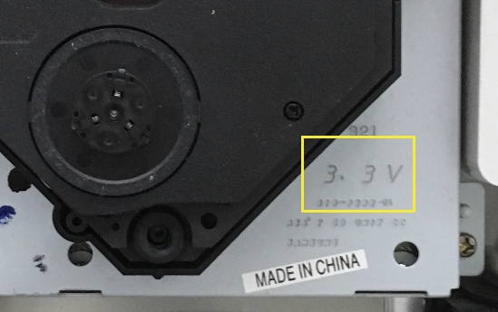

**Disassembly:**

Ignore the state of the Dreamcast, this is my spare (I’ll be leaving my original launch day machine intact), and I’ve spray-painted it! I never usually advocate paint-jobs on hardware (unless it’s to restore original colours, as I did for my [**Atari 800XE**](https://retrogamesultra.com/2017/04/29/spray-painting-the-atari-xe-line-of-8-bits/)), but this was really yellow and grimy. Picture of what it looks like at the end!

First of all, turn the Dreamcast upside down and remove the modem by pushing gently in on the ridged thumbgrip, and sliding out.

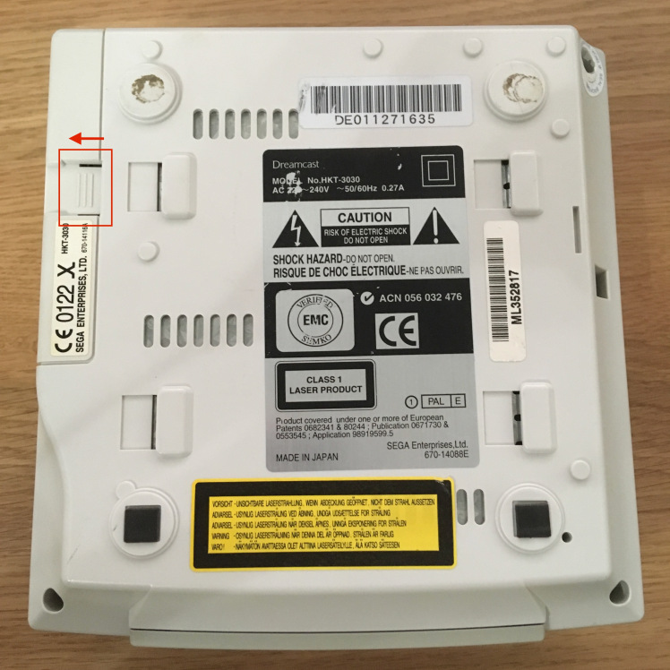

With the modem removed, unscrew the four corner case screws:

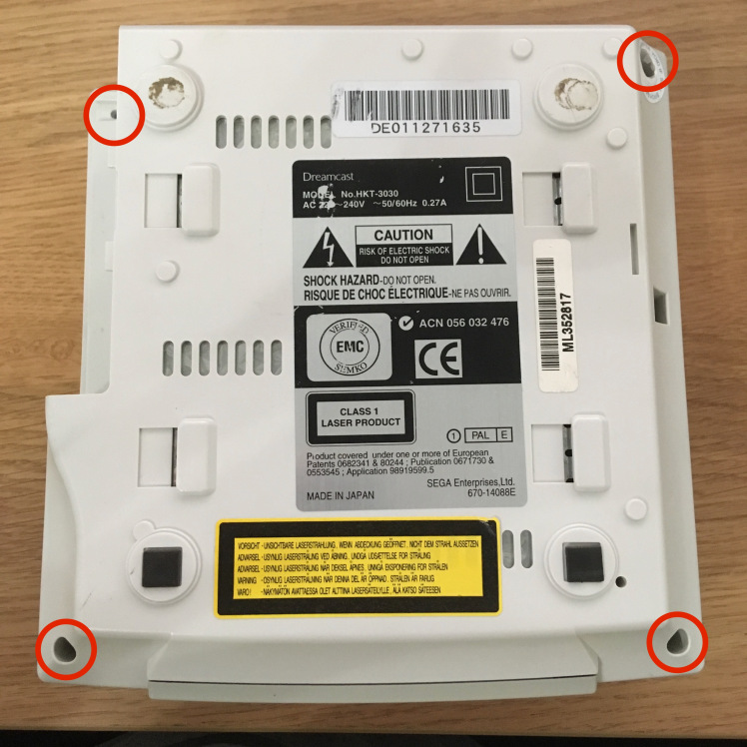

Holding the two halves of the case together, turn the Dreamcast back the right way up and gently lift off the top cover.

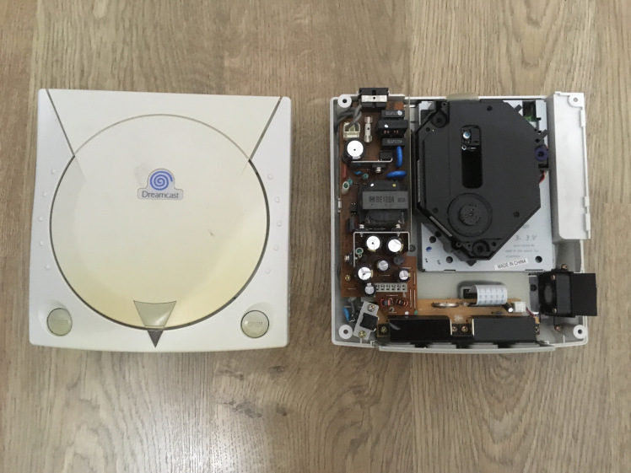

This is a good time to check the capacitors for visual signs of expansion. Mine were fine, but knowing the battery had died, I changed the soldered-on one for a holder for ML2032 batteries (ML2032 are rechargeable, so CR2032 batteries (which are not rechargeable) should NOT be used), and I also changed the orange power LED for a blue one while I was in there. To do those mods are VERY simple – and just require very basic soldering skills.

Next step is to remove the drive assembly. Unscrew the three holding screws:

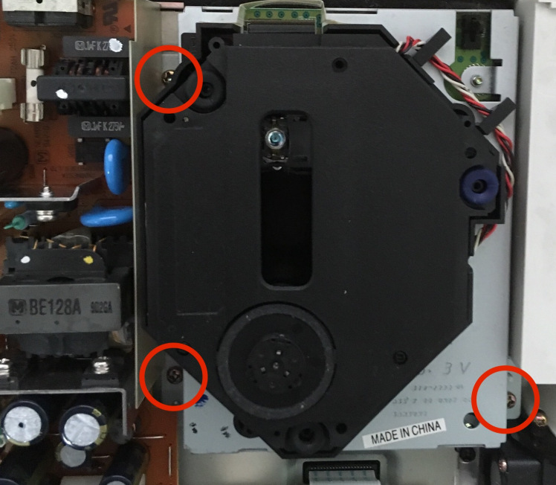

Now, without twisting or tilting the unit, and holding either the metal cage, or the smooth black plastic outer wall, lift the unit straight up and out. The pin connector is bottom-right as you look at the picture above, close to the screw hole. You’ve now exposed the connector:

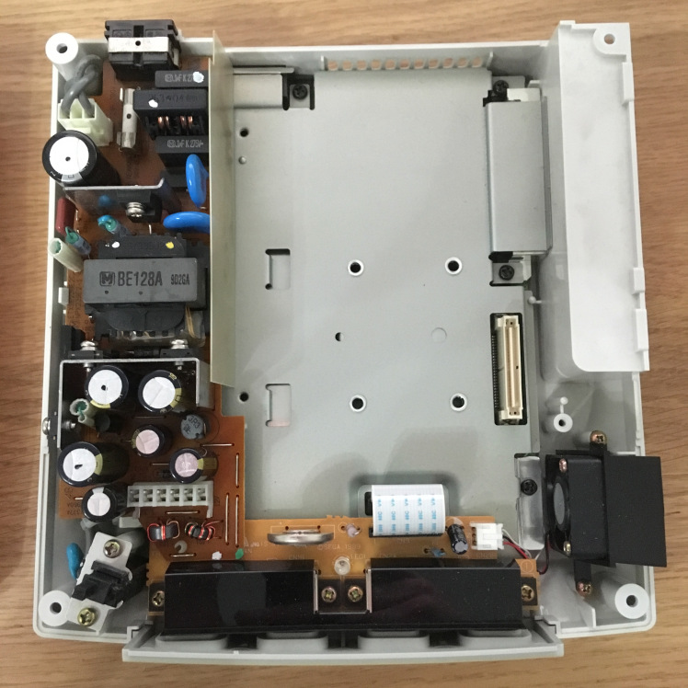

**Installation:**

Put the two plastic standoffs into the top edge of the GDEMU board, before lowering it into place. The instructions for the original GDEMU say that the bottom-left hole needs an M3 20mm screw with button- or pan-head. This would work, but you’d need an appropriate standoff (which I didn’t have). Also, my clone board didn’t come with a screw for that hole at all, but – and I do this often – Blu-Tack makes for a great temporary support until you can find the right part! Again, try not to twist, tilt, or bend the board as you lower it.

With the 3D-printed tray I fitted (see later in this post) I found a solution.

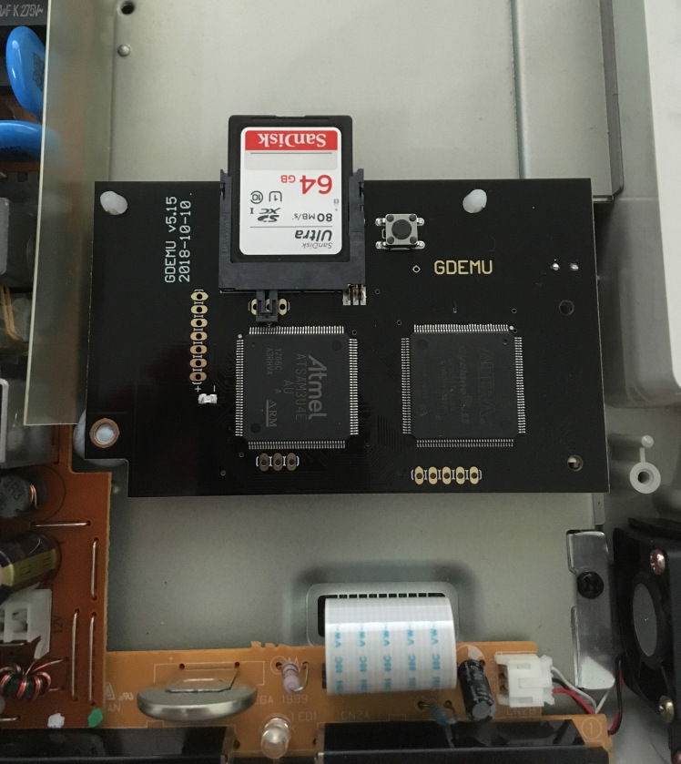

At the end of this post I’ve put details of the 3D-printed ‘tray’ I’ve installed. There are a variety of designs people have created – I’ve gone for one with integrated SD card storage slots. That will allow me some degree of easy categorisation of GDI files on different cards.

Put the lid back on your Dreamcast, carefully turn it over, and put the four corner screws back in. You can slide the modem back in now, too.

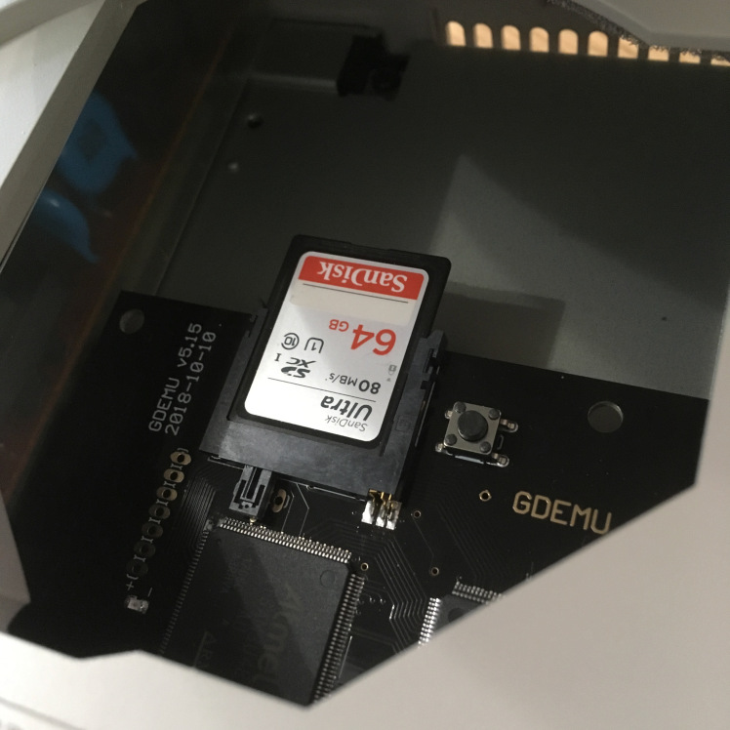

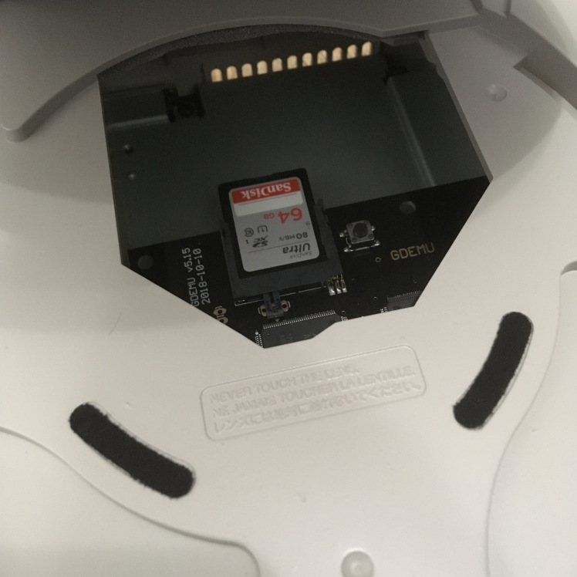

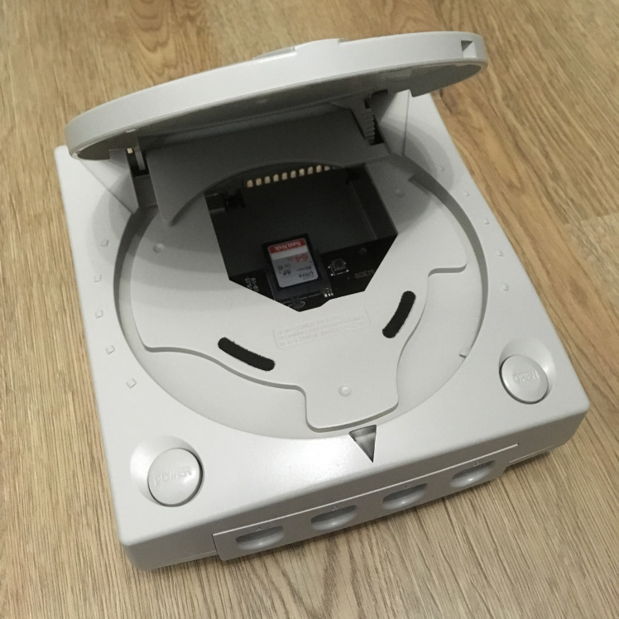

Keep the GDROM drive safe, and particularly the screws!

**Optional (but recommended) power modification:**

With the GD-ROM gone, the 12V rail that powered it is no longer having that draw on it, so can output up to 14V, causing your Dreamcast to get very, very hot, and may shorten the lifespan of components. The 3D printed tray I’m fitting will help airflow, but if you’re not fitting one, some people recommend you put in some paper to help the fan draw air correctly over the PSU, as can be seen in this [**crude example**](https://imgur.com/a/AXCLy). To rectify this effectively, a simple mod adding some resistors will bring the voltage back down. This information originally came from [**this post**](https://www.dreamcast-talk.com/forum/viewtopic.php?f=42&t=10392), and at 01:40 in the second video down the page, you can see where it needs to go. Further discussions with two awesome people, one an electronics expert, have made me alter the modification slightly. He advised that a 300ohm 1/4W resistor isn’t really going to cut the mustard as it will itself get too hot. If you’re going to go for a single resistor, 1W is better. Further to that, 330ohm is better than 300ohm as it will lower the amperage output, and that’s what’s going to make more difference to the heat generation. Even better than that is three 1Kohm 1/4W resistors in parallel (creating a resistance of 333.33ohm), as the load is shared between the three.

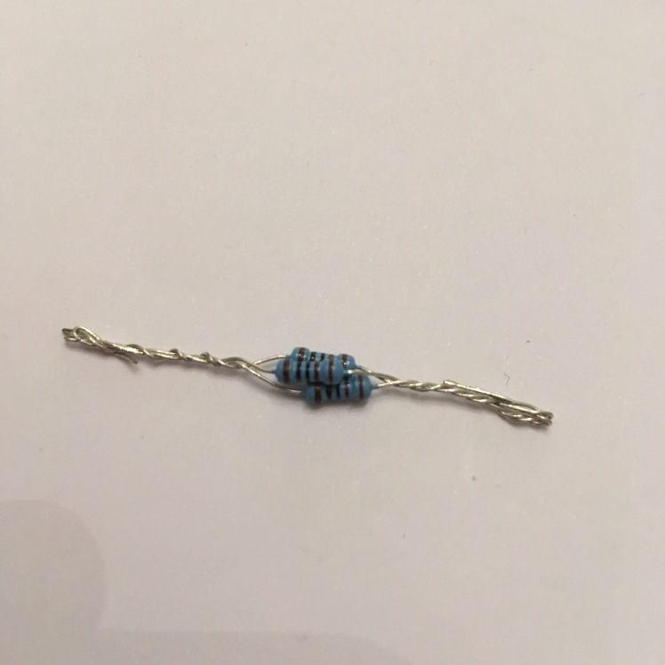

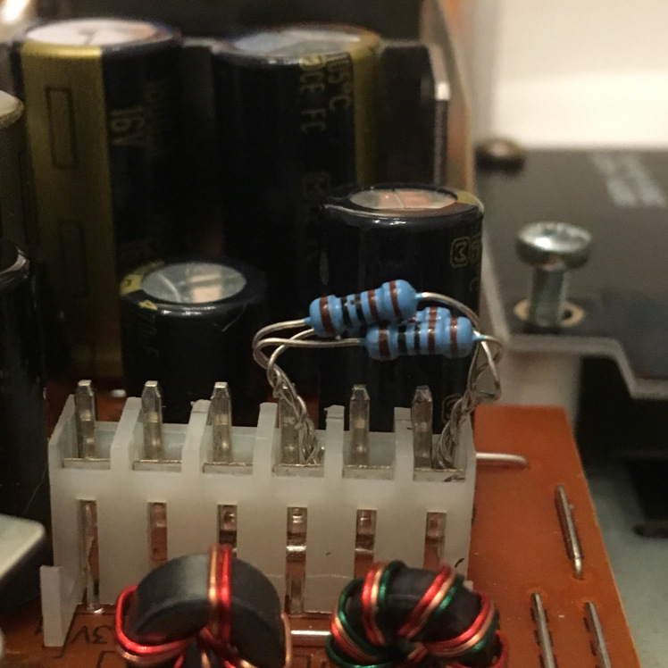

**Software and SD card preparation / filling:**

You’ll need an SD/SDHC card, or Micro SD/SDHC card with an adapter. Good quality cards are recommended, and I’ve had success with the SanDisk Ultra cards as pictured above. The official technical requirements for the cards are:

SD: 512MB, 1GB, 2GB  
SDHC: 4GB, 8GB, 16GB, 32GB

4GB SD cards are NOT supported. I use a 64GB card with no problems, and others have used 128GB successfully, too.

Ensure your card is formatted as FAT16 for capacities up to and including 2GB, and FAT32 for 4GB and above. Lots of SDHC cards will come pre-formatted as ExFAT so will need to be reformatted. The SD Association’s own software will auto-format to ExFAT and so you may need to use alternative software, or just directly from your OS.

You can fill your card manually (see instructions on the [**official site**](https://gdemu.wordpress.com/details/gdemu-details/)), but by far the easiest way is with a piece of Windows software called GDEMU SD Card Maker. You can [**click here**](https://drive.google.com/open?id=1ytI2ydRN7IPStAU25F1QwMPgZd0Zym-g) to download version 1.10. Supported file formats of GDEMU are GDI, CDI, CCD+IMG+SUB, MDS+MDF, and ISO. I’ve successfully used GDI files in folders (they must be in folders) and CDI files, but haven’t tried any others.

One thing to bear in mind is that GDI files (and their associated folder of contents) can be an entire rip of a GD-ROM, so the file size once on your SD card will be just over 1.1GB each. These can be trimmed with other software, or many CDI files only have data actually used so will be smaller, but some may not work. I use original GDI rips to try and achieve the highest compatibility I can, and SD cards are cheap enough at the moment that I don’t mind having multiple cards to fit on the games I want.

When you open SD Card Maker, the first thing to do is make sure that your SD card is showing as the corresponding system drive letter in the top left. Next, tick the ‘Menu’ checkbox in the bottom right. This runs a patch that can prevent the game list from taking a long time to appear on your Dreamcast. Sometimes it works, sometimes it doesn’t!

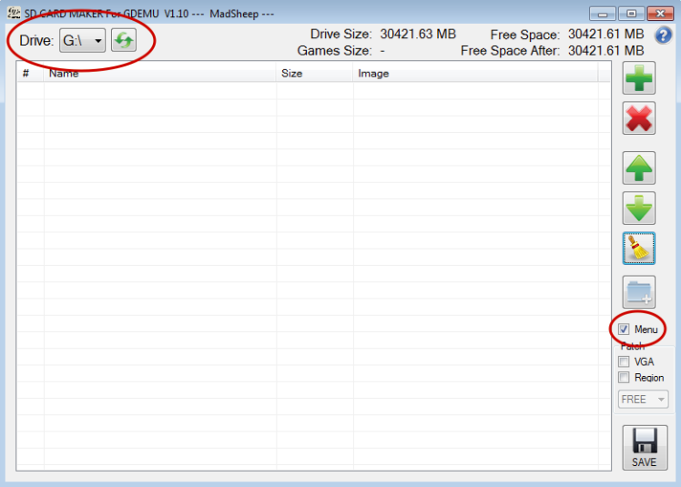

Next, add your games. You can either press the green plus symbol in the top right to add via a file browser, or you can just drag and drop files into the list.

At the top right of the window you’ll see ‘Free Space’, telling you the capacity of your SD card, and just underneath, ‘Free Space After’, telling you the free space that would be left on the card if you finalised it with whatever is currently in the game list.

Two things to note on file naming and ordering. You can reorder them by:

1. Using the green up and down arrows to move the selected title up or down one step at a time.
2. Drag a title and drop it where you want it to be.
3. Click on the ‘Name’ header to sort the entire list alphabetically, A-Z, or Z-A.
4. You can add an empty folder using the blue folder with a white ‘+’ icon on it which will act as a separator, so that you can group titles.

NOTE: At this stage, some names will be different to the folder name (or filename in the case of CDIs) that you added. In the worst cases, when the files have not been tagged you will see a blank entry in the list, or they may be tagged with something they were built from, for example a homebrew game may have used an Official Dreamcast Magazine coverdisc as its basis and may still have that tagged name! You *cannot* rename titles in this section of the application, but in the next you can, so its important that you make a note of which position your titles are in so that you can name them appropriately in the next step. In addition, be sure to place the titles where you want them to be AFTER you have renamed them in step 2, as you can’t reorder them there.

Once you’ve put what you want on the card, and sorted them appropriately, click the big ‘SAVE’ button in the bottom right.

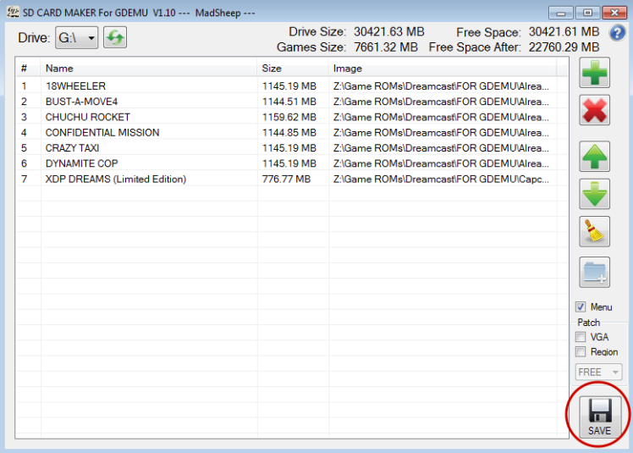

You will be asked if you want to customise your menu. If you want to rename any of the titles, then say yes. To rename, click into the name field and overtype. IMPORTANT: The software will place a new item, ‘GDMENU’ at position 01. Leave that as it is. When you’re finished, click DONE.

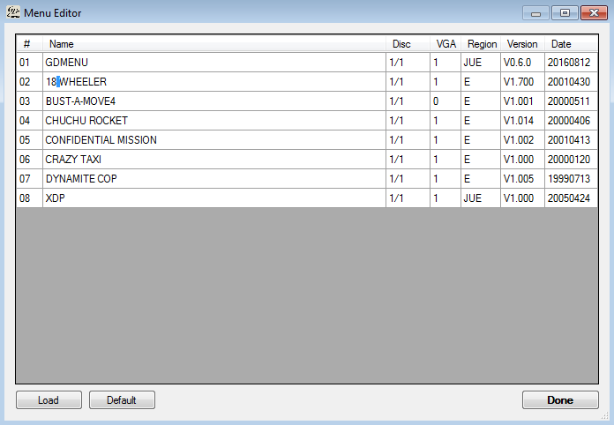

The software will fill your card:

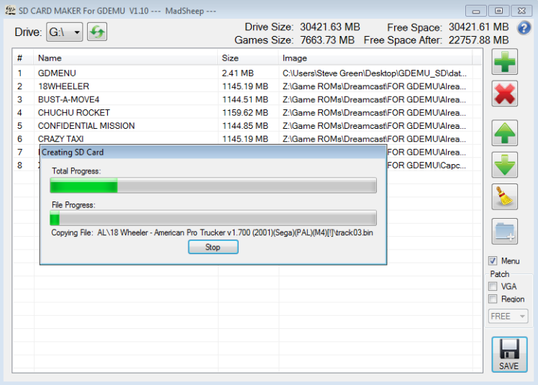

Once it’s finished, you should see this message:

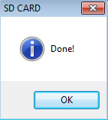

The first time I did it I got an error message like this:

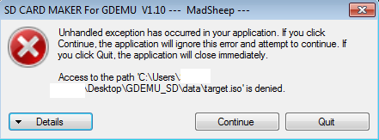

I believe this was down to my antivirus software – creating an exception in its block list seemed to fix it. In any case, this error does not impact the SD card in any way, that is OK to use even if you see this message.

Within the SD Card Maker folder, you’ll find a readme for the GD MENU software that it installs on your card, and is what you see when you boot the Dreamcast. I highly recommend reading it as it gives key combos for resetting the system and information on region settings / VGA output, and it can be found here: GDEMU_SD > data > files > readme.txt. I’ve also made it available at [**this link.**](https://drive.google.com/open?id=1O2YQ01EaHPtrlfOUKivWptv2FKWhfuwT)

As a TL:DR, though, two useful bits of info: In-game reset, hold A+B+X+Y+START. Some games will make this first reset to their menu, and you do it again to go back to GD MENU. The other is that the software skips the BIOS region check, so in almost all cases, it doesn’t matter if your game files are PAL or NTSC, the system will play them with no specific patching required.

**3D-printed tray:**

As mentioned earlier, rather than leave the board ‘bare’ inside the DC (where it can be easy to drop and lose the SD cards inside the case!) I had [**this tray**](https://www.thingiverse.com/thing:1585333) made. The creator has options for SD slots on the left, right, or none, and it also mimics the shape of the original GD-ROM drive to try and create the original airflow for cooling. The storage slots are great, and it gives it a nice, purpose-built look. I’m just sad I’d already ordered it in white before I decided to spray the DC!

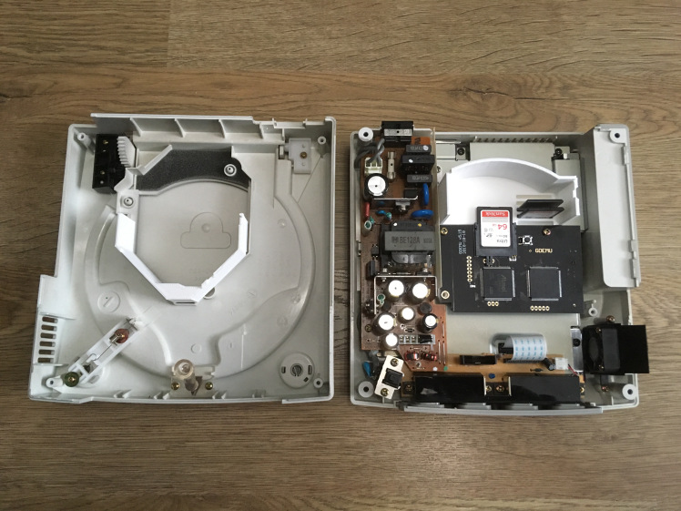

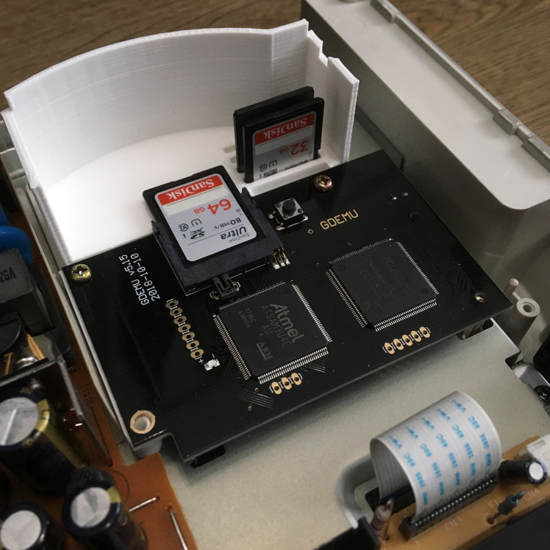

That annoying bottom left hole? Now there’s a built-in standoff on the tray, an M3 16mm with the bottom half of a screw cover (like those used on car registration plates) acting as a spacer was a perfect fit.

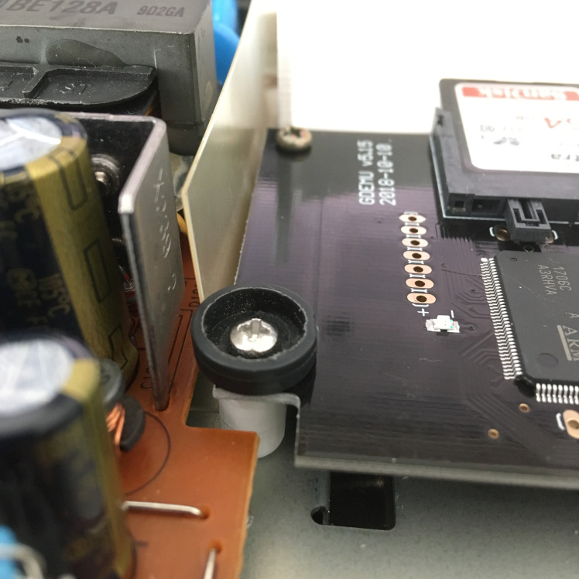

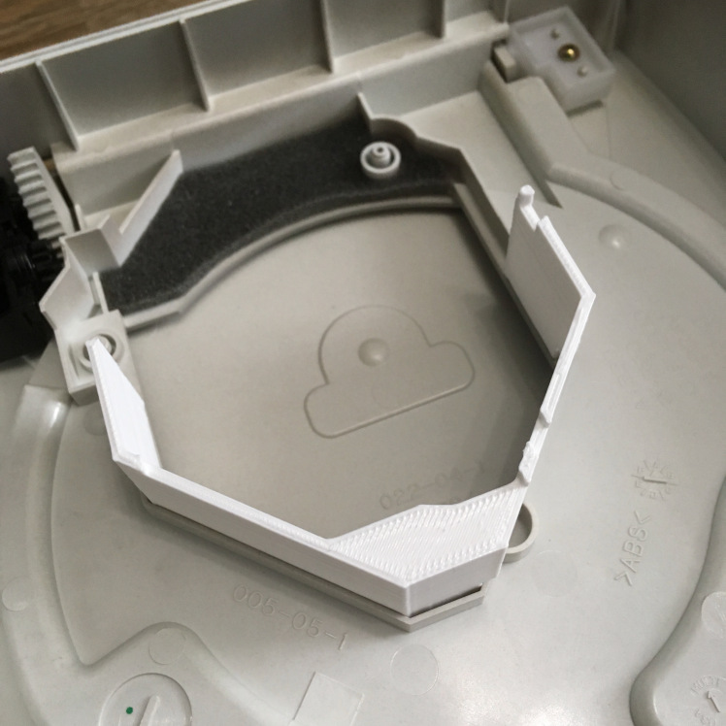

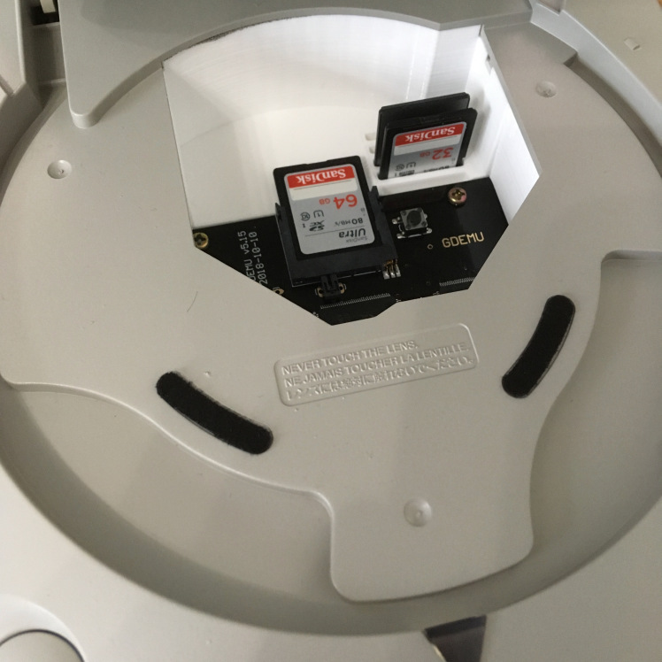

**Game on!**

…

And for those interested, here’s what it looked like after the spray job and LED change!

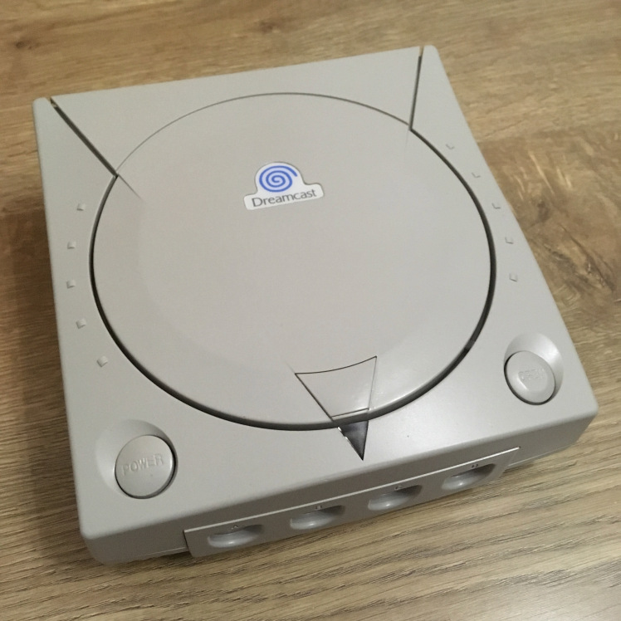

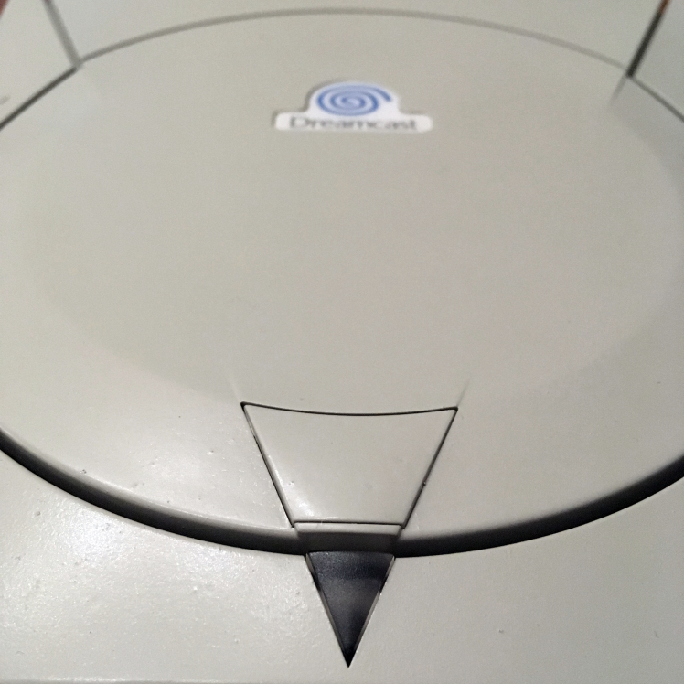

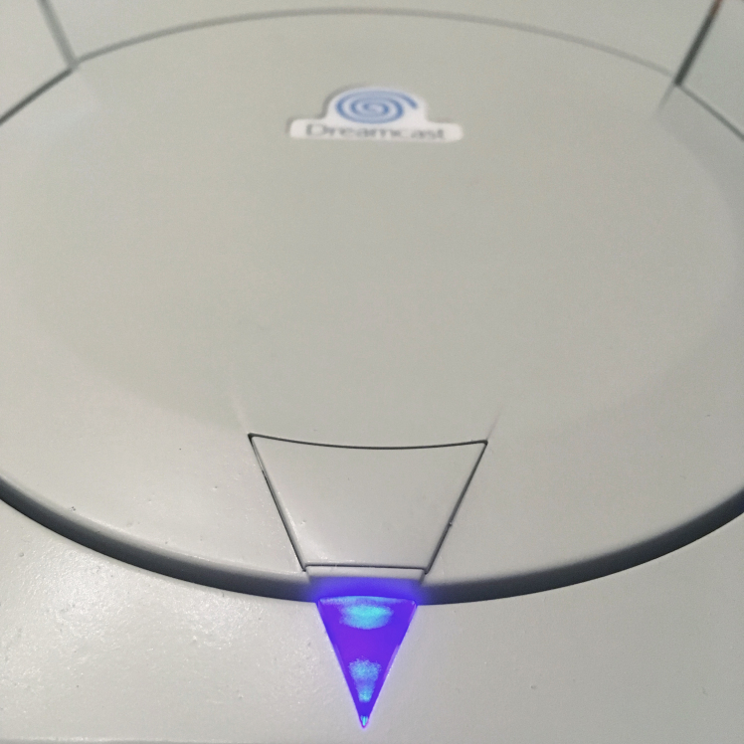

Here’s my untouched launch-day model next to the sprayed one:

